AI POWERED CROP DISEASE DETECTION AND RECOMMENDATION SYSTEM FOR SUSTAINABLE DEVELOPMENT
Design and Implementation
Department of Computer Science and Engineering, [COLLEGE NAME]
Batch C16 (CSE-C) · Academic year [ACADEMIC YEAR]
Table 1: Project team
S.No. | Student name | Roll number
1 | Pishke Vishal | 23K91A05J2
2 | Kyatham Nithisha | 23K91A05D1
3 | Mekala Tharun Kuruma | 23K91A05F1
4 | Nakka Sreenith | 23K91A05H0

Project guide: V Krishna Teja
Chapter and section numbers quoted in the text (for example Chapter 8 or Section 6.2) refer to the full project report, 17.Final Document. Figures and tables in this document are numbered from 1.

1. DESIGN

1.1 Design goals and constraints
AgriVision has to let a farmer with a phone or a laptop send one leaf photograph and read, in a few seconds, what the system thinks the disease is, how urgent it is and what to do about it. The design therefore starts from five goals taken from the objectives (Chapter 1): a single deployable stack that runs on one ordinary PC; a diagnosis step that can be replaced when a better model is available without touching the rest of the application; advice that comes from a curated knowledge base rather than from the model; an interface that is usable in English, Hindi and Marathi on a phone-sized screen; and honest reporting, so that the application states which engine produced a result.
• One stack, one command. Python 3.10 or newer and Node.js 20 or newer; run.bat creates the environment and starts both servers. No GPU, no cloud service and no paid API are needed.
• Replaceable engine. inference.predict() is the only function that looks at pixels. It returns the same dictionary whether the answer comes from the heuristic or from a Keras or ONNX network.
• Reuse, not rewrite. The original Flask product (agrivision/) already held the knowledge base, the detection function and the tables. The FastAPI layer imports these modules unchanged and adds only a JSON login, serialisers and a few reports, so a scan made through either interface appears in the other.
• Privacy by ownership. Every scan belongs to one user; reading, exporting or deleting it requires that user's token and returns 404 to anybody else.
• Visible limits. The sidebar, the landing page and every result show the engine name and a note that the score is not a calibrated probability.

1.2 System architecture
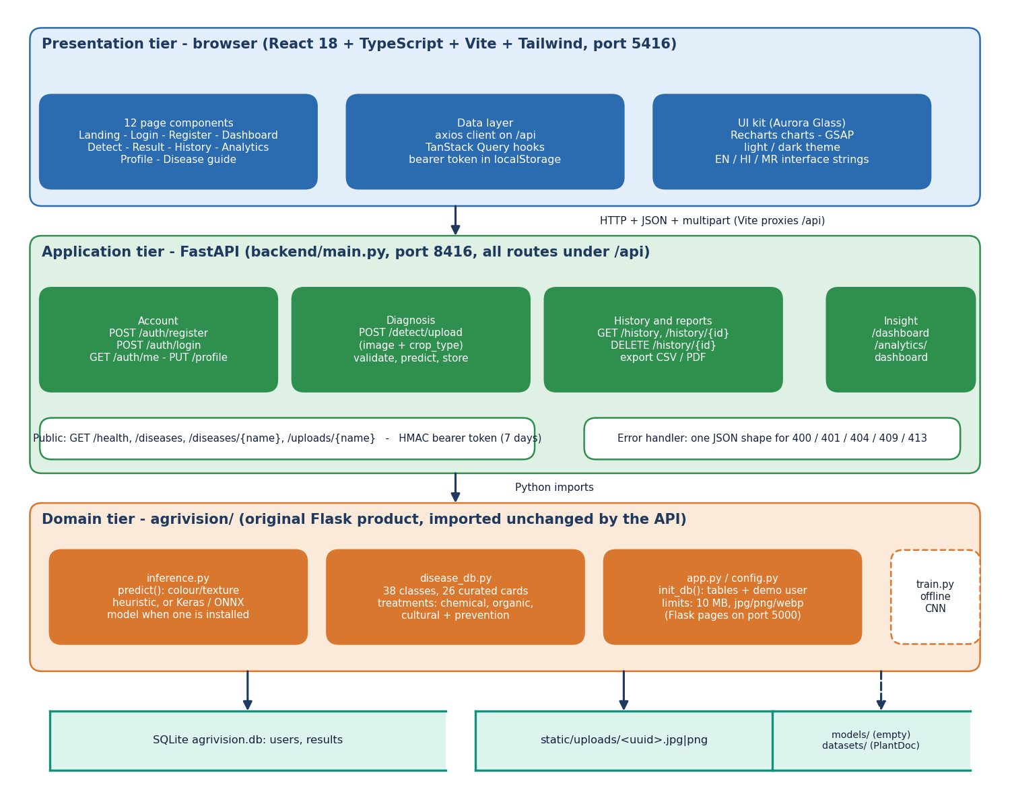
Figure 1: Three-tier architecture of AgriVision: browser, FastAPI service, original Flask modules, and the data stores.
The browser tier is a React single-page application (twelve page components, axios client, TanStack Query hooks, English, Hindi and Marathi interface strings) served by Vite on port 5416, which proxies every /api request to the application tier. The application tier is backend/main.py: sixteen FastAPI routes grouped into account, diagnosis, history and reports, and insight (dashboard and analytics), plus public routes for health, the disease guide and uploaded images. The domain tier is the unchanged Flask product in agrivision/: inference.py (the diagnosis engine), disease_db.py (the 38-class knowledge base) and app.py/config.py (table creation, limits). Below them sit the SQLite file with the users and results tables, the folder of uploaded images, and the offline models/ and datasets/ folders. The models/ folder is empty in the shipped product.
Table 2: Tiers and their modules
Tier | Module | Responsibility | Size
Presentation | frontend/src (React 18, Vite 8, TypeScript 5.9, Tailwind 4) | 12 page components, axios client, TanStack Query hooks, theme and language providers, UI kit | 5,647 lines
Application | backend/main.py (FastAPI) | 16 routes, HMAC bearer token, serialisers, CSV and PDF export, error format | 437 lines
Domain | agrivision/inference.py | Diagnosis engine: heuristic or Keras/ONNX model, crop candidates, label map | 177 lines
Domain | agrivision/disease_db.py | 38 class labels, 26 curated cards, generic treatments by disease kind | 221 lines
Domain | agrivision/app.py, config.py | Table creation, demo user, limits (10 MB; jpg, jpeg, png, webp); original Flask pages | 404 lines
Data | agrivision.db, static/uploads/ | Tables users and results; uploaded images under random names | -
Offline | agrivision/train.py, scripts/run_experiments.py | CNN training script of the original product; seeded measurements | 103 + 430 lines

1.3 High-level workflow
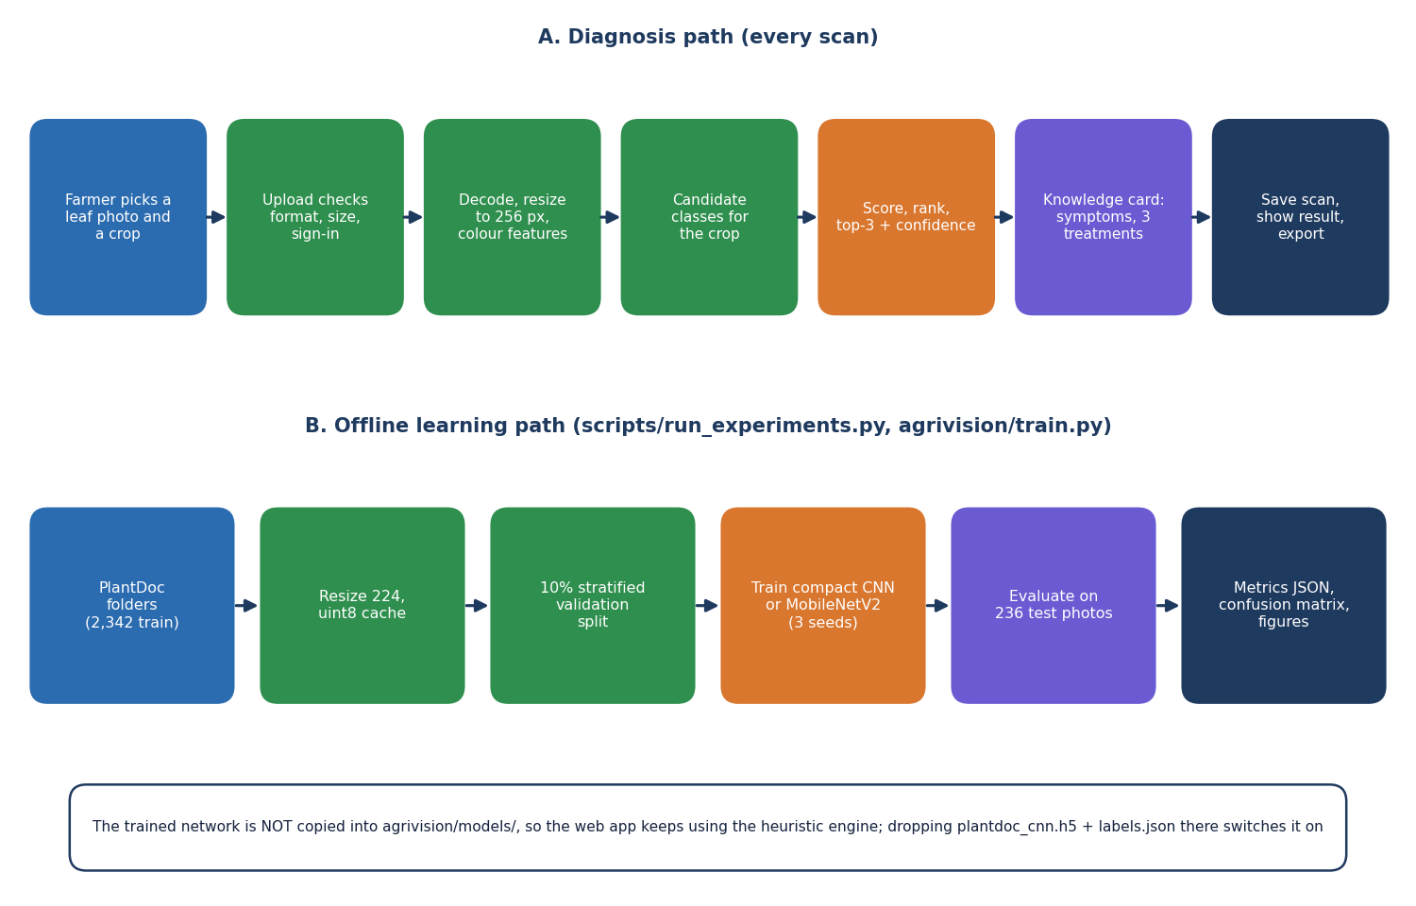
Figure 2: High-level workflow: the diagnosis path used on every scan, and the offline learning path used to measure accuracy.
The upper row is what happens when a farmer scans a leaf: the photograph and crop are uploaded, the service checks the sign-in, the file extension, size and emptiness, the engine decodes and resizes the image to 256 pixels and measures colour and texture shares, the candidate classes of the chosen crop are selected, the classes are scored and ranked, the top three are returned with a confidence, the knowledge card of the top class supplies symptoms and three treatments, and the scan is stored and shown. The lower row is the offline path that produced the accuracy figures in this report: PlantDoc folders are resized to 224 pixels, a stratified 10 % validation split is taken, models are trained with three seeds and evaluated on the 236 test photographs. The trained network is not copied into the application.
The diagnosis path contains no learning in the shipped product: the engine is a fixed formula, which is why its accuracy is measured separately in Chapter 8. The offline path is the only place where data are used to fit anything, and its protocol is kept away from the test photographs on purpose.

1.4 Data flow diagrams

1.4.1 Level 0: context
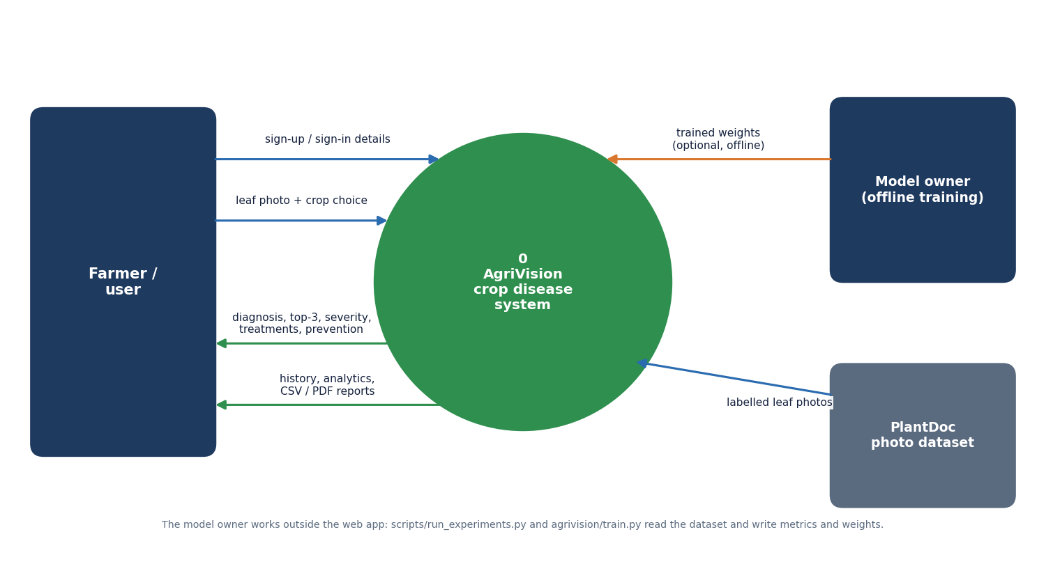
Figure 3: Context diagram (DFD level 0) of AgriVision.
The whole system is one process, 0 AgriVision. The farmer sends sign-up and sign-in details and a leaf photograph with a crop choice, and receives the diagnosis with the top three predictions, severity, treatments and prevention advice, and the history, analytics and exported CSV or PDF reports. The model owner and the PlantDoc dataset are drawn as external entities because they work outside the web application: the dataset supplies labelled leaf photographs to the training and measurement scripts, and the model owner may return trained weights that inference.py would load if they were placed in agrivision/models/.

1.4.2 Level 1: processes and stores
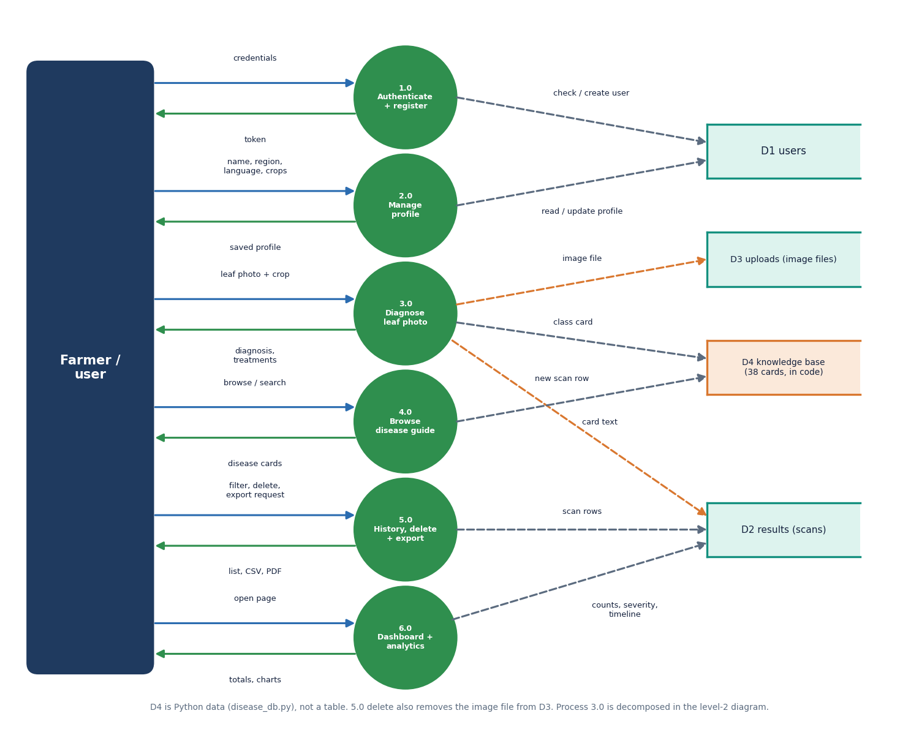
Figure 4: DFD level 1: six processes and four data stores.
Level 1 splits the system into six processes: 1.0 Authenticate and register (reads and writes D1 users and returns a token), 2.0 Manage profile (language, region, crops), 3.0 Diagnose leaf photo (writes the image file to D3 uploads and a scan row to D2 results, reads a card from D4), 4.0 Browse the disease guide (reads D4), 5.0 History, delete and export (reads and deletes D2 rows and D3 files, produces CSV and PDF), and 6.0 Dashboard and analytics (counts and groups D2 rows). D4, the knowledge base of 38 cards, is Python data in disease_db.py and not a database table. Every process except 4.0 requires the bearer token; process 4.0 and the card lookup are public.
Table 3: DFD level 1 processes and the routes that implement them
Process | Name | Routes (backend/main.py) | Stores touched
1.0 | Authenticate and register | POST /auth/register, POST /auth/login, GET /auth/me | D1 read and write
2.0 | Manage profile | PUT /profile | D1 read and write
3.0 | Diagnose leaf photo | POST /detect/upload | D2 write, D3 write, D4 read
4.0 | Browse the disease guide | GET /diseases, GET /diseases/{name} | D4 read
5.0 | History, delete and export | GET /history, GET /history/{id}, DELETE /history/{id}, GET /history/export, GET /history/{id}/export | D2 read and delete, D3 delete, D4 read
6.0 | Dashboard and analytics | GET /dashboard, GET /analytics/dashboard | D2 read, D4 read

1.4.3 Level 2: process 3.0
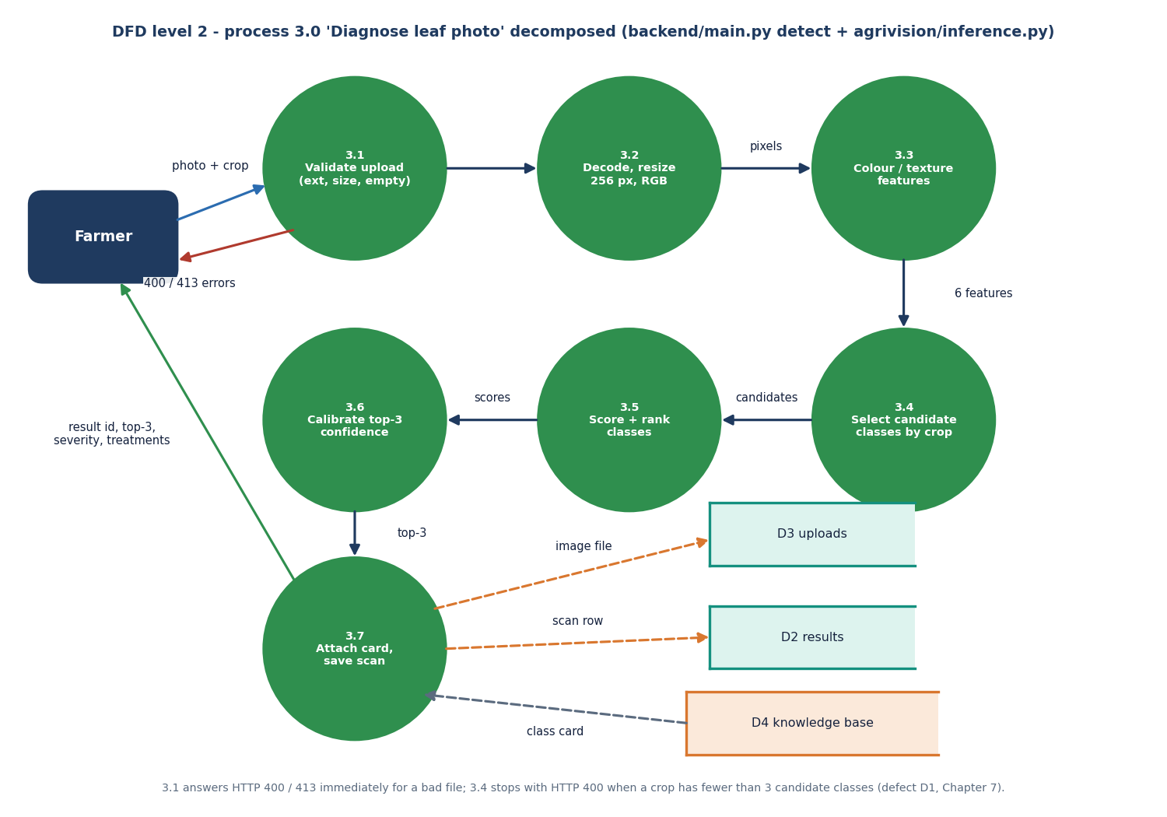
Figure 5: DFD level 2: process 3.0 'Diagnose leaf photo' decomposed into seven sub-processes.
Process 3.0 is decomposed into 3.1 Validate upload (extension, 10 MB limit, empty file), 3.2 Decode and resize to 256 x 256 RGB, 3.3 Colour and texture features (green, brown, yellow, dark and white pixel shares and the global standard deviation), 3.4 Select candidate classes by crop, 3.5 Score and rank the classes, 3.6 Calibrate the top-three confidence, and 3.7 Attach the knowledge card and save the scan. Errors leave from 3.1 (HTTP 400 or 413) and from 3.4, where a crop with fewer than three candidate classes raises an exception that the API reports as HTTP 400 (defect D1). Process 3.5 and 3.6 are replaced by a single network forward pass when a trained model file is installed.

1.5 UML diagrams

1.5.1 Class (module) diagram
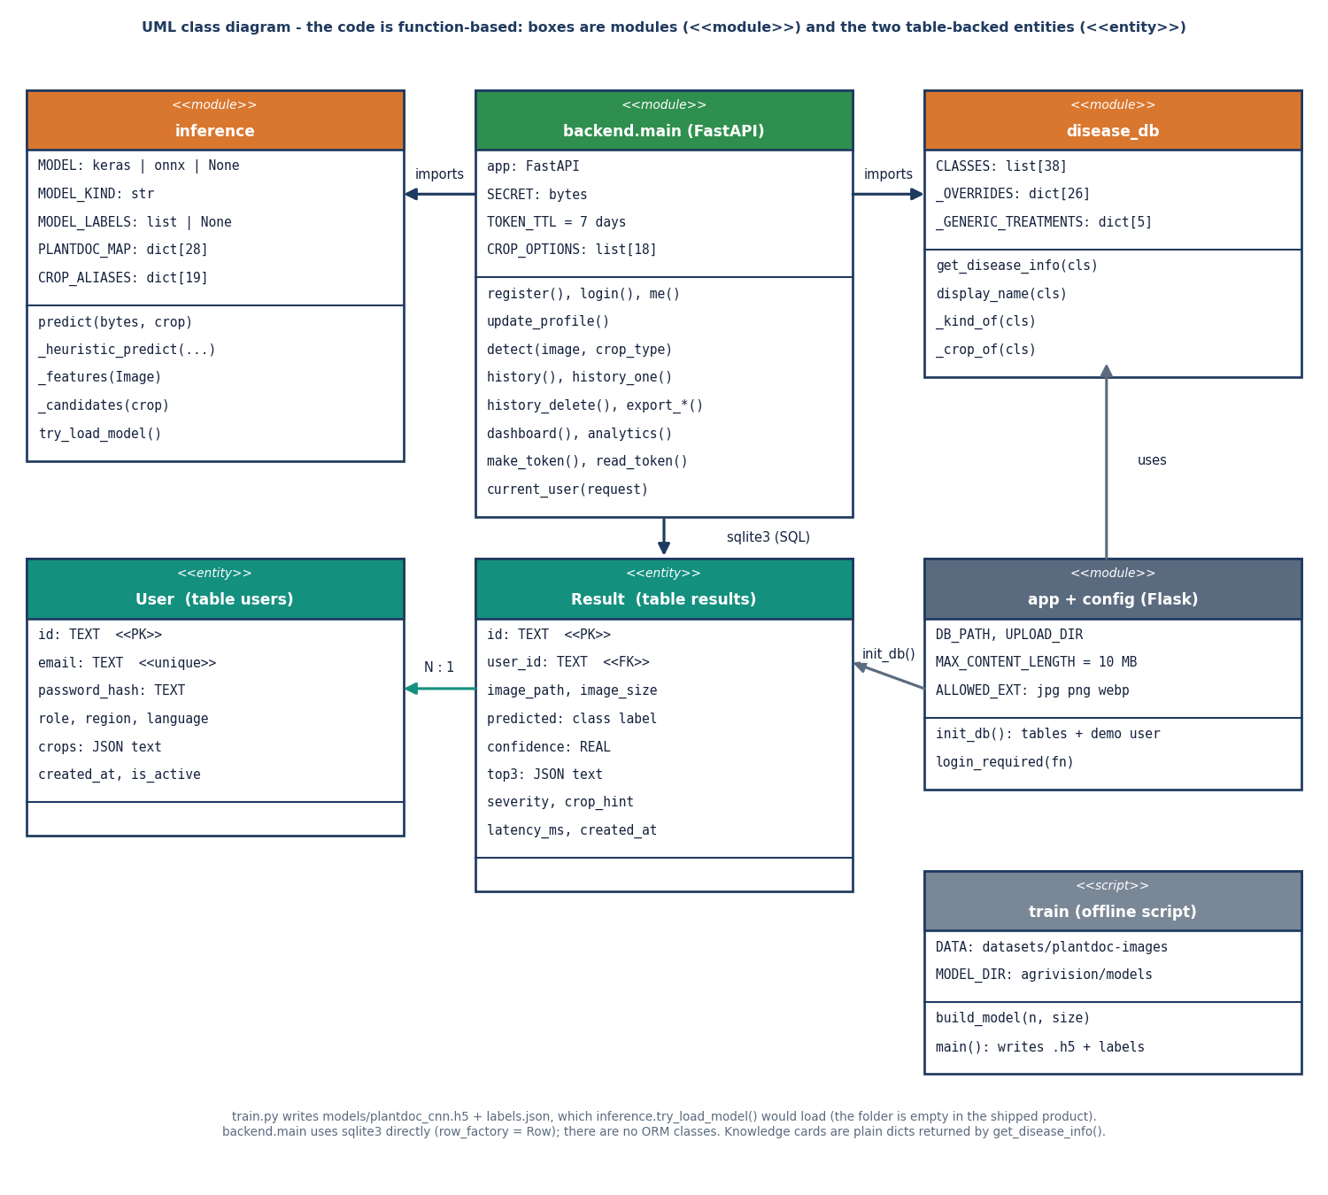
Figure 6: UML class diagram: modules of the application and the two table-backed entities.
The product is written with functions and modules rather than classes, so the diagram shows modules with the stereotype module and the two persistent entities User and Result with the stereotype entity. backend.main imports inference (the engine, with the optional model, its labels and the PlantDoc label map) and disease_db (the 38 class labels, 26 curated overrides and five generic treatment kinds). app and config hold the limits and init_db(), which creates the tables and the demo user. train is an offline script that writes the weights inference.try_load_model() would load. One User has many Results through user_id; the code reads and writes them with sqlite3 directly, without an object-relational mapper.

1.5.2 Sequence diagram
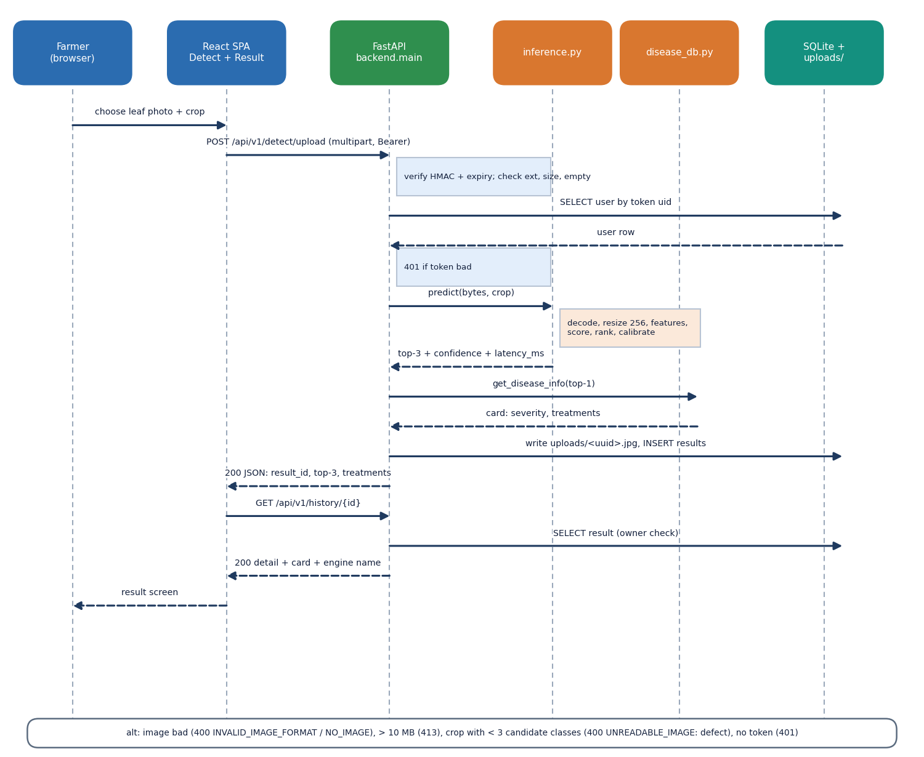
Figure 7: Sequence diagram: uploading a leaf photograph and opening the result.
The sequence follows one diagnosis. The farmer chooses a photograph and crop in the Detect page; the SPA posts the multipart form to /api/v1/detect/upload with the bearer token. The service verifies the HMAC signature and expiry, reads the user row, checks the extension, size and emptiness, and calls predict(). The engine returns the top three classes, the confidence and the latency; the service asks disease_db for the card of the top class, writes the image under a random name, inserts the result row and answers with the result id, the top three, the severity and the treatments. The SPA then requests /api/v1/history/{id}, the service checks that the scan belongs to the user, and the Result page is drawn. The bottom box lists the alternative outcomes: 400, 413 and 401.

1.5.3 Use case diagram
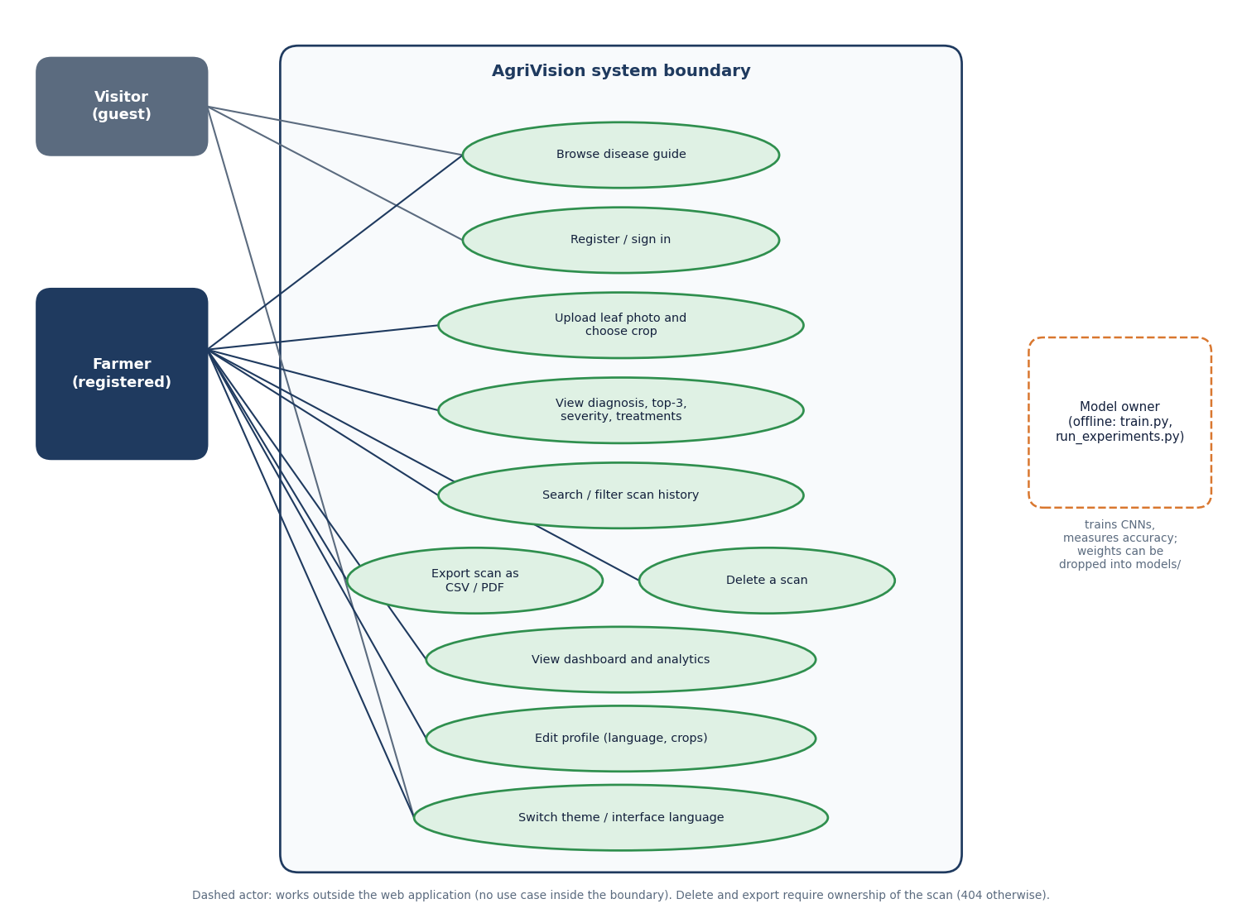
Figure 8: Use case diagram: visitor, registered farmer and the offline model owner.
A visitor can browse the public disease guide, register or sign in and change the theme or interface language. A registered farmer can additionally upload a leaf photograph and choose a crop, view the diagnosis with top three, severity and treatments, search and filter the scan history, export one scan as CSV or PDF, delete a scan, open the dashboard and analytics, and edit the profile (language and crops). Export and delete are limited to the owner of the scan: any other user receives 404. The model owner is drawn with a dashed outline because the actor works outside the web application, running train.py and run_experiments.py and, if wished, installing trained weights.
Table 4: Use cases and the screens that realise them
Use case | Actor | Screen | Route
Browse the disease guide | Visitor, farmer | Disease guide, Disease detail | GET /diseases
Register or sign in | Visitor | Register, Login | POST /auth/register, /auth/login
Upload a leaf photo and choose the crop | Farmer | Detect | POST /detect/upload
View diagnosis, top three, treatments | Farmer | Result | GET /history/{id}
Search and filter history | Farmer | History | GET /history?q=&crop=&disease=
Export one scan (CSV, PDF) or all (CSV) | Farmer | Result, History | GET /history/{id}/export, /history/export
Delete a scan | Farmer | History, Result | DELETE /history/{id}
Dashboard and analytics | Farmer | Dashboard, Analytics | GET /dashboard, /analytics/dashboard
Edit profile (language, crops) | Farmer | Profile | PUT /profile
Train and measure models | Model owner | (command line) | train.py, run_experiments.py

1.6 Database design
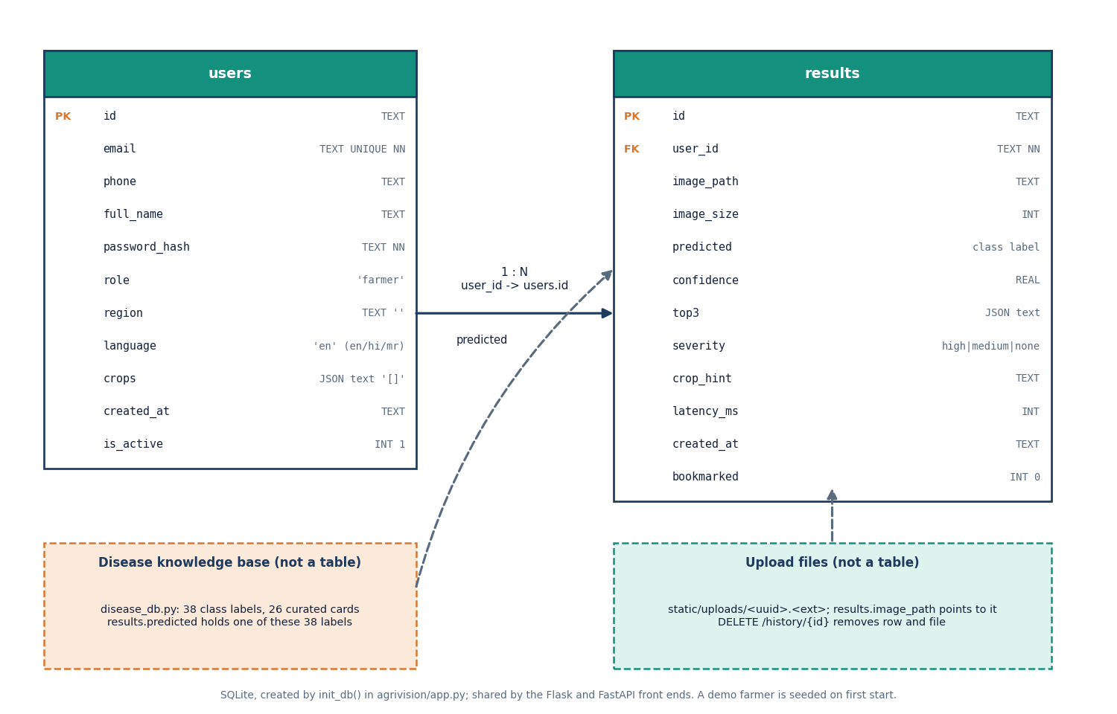
Figure 9: Entity-relationship diagram of the SQLite database (tables users and results).
The database has two tables created by init_db(). users holds the account (id, unique email, phone, name, password hash, role, region, language, a JSON text list of crops, creation time and an active flag). results holds one row per scan (id, user_id, image path and size, the predicted class label, confidence, a JSON text copy of the top three, severity, the crop hint, latency and time, and a bookmark flag). The relation is one user to many results. The disease knowledge base and the image files are drawn as dashed boxes because they are not tables: results.predicted stores one of the 38 class labels and results.image_path points to a file in static/uploads.
Table 5: Table users
Column | Type | Constraint or default | Meaning
id | TEXT | PRIMARY KEY (UUID) | Account identifier, also the uid inside the token
email | TEXT | UNIQUE NOT NULL | Login name; stored lower-case
phone, full_name | TEXT | - | Optional contact and display name
password_hash | TEXT | NOT NULL | Salted hash made by werkzeug.security.generate_password_hash
role | TEXT | 'farmer' | Only the value farmer is used
region, language | TEXT | '' and 'en' | Language is en, hi or mr
crops | TEXT | '[]' | JSON list of monitored crops; tomato is stored when none is chosen
created_at | TEXT | - | ISO time (UTC)
is_active | INTEGER | 1 | Sign-in and token checks require 1

Table 6: Table results
Column | Type | Constraint or default | Meaning
id | TEXT | PRIMARY KEY (UUID) | Scan identifier used in /result/{id}
user_id | TEXT | NOT NULL, FOREIGN KEY users(id) | Owner of the scan
image_path, image_size | TEXT, INTEGER | - | static/uploads/<uuid>.<ext> and size in bytes
predicted | TEXT | - | One of the 38 canonical class labels
confidence | REAL | - | Score of the top class (not a calibrated probability for the heuristic)
top3 | TEXT | - | JSON list of [class, score] pairs
severity | TEXT | - | high, medium or none (copied from the card)
crop_hint, latency_ms | TEXT, INTEGER | - | Crop chosen by the user; engine time reported by predict()
created_at, bookmarked | TEXT, INTEGER | 0 | ISO time; bookmark flag (not used by the React screens)

Design notes. The foreign key is declared but SQLite enforces it only when PRAGMA foreign_keys=ON is set per connection, which neither app.py nor backend/main.py does; the ownership rule is enforced in the queries (WHERE id=? AND user_id=?). The INSERT INTO results VALUES(...) statement is positional, so a column added to the table would break both front ends; this is why the database was left untouched during the rebuild. Arrays are stored as JSON text because the lists are short and always read together with their row.

1.7 Module design

1.7.1 Backend modules
Table 7: Backend functions and their roles
Function (backend/main.py) | Role
make_token, read_token, current_user | Create and check the HMAC-SHA256 bearer token (7 days); load the active user or answer 401
get_db, init_db (from app.py) | One SQLite connection per request with row_factory = Row; create tables and the demo user at start-up
register, login, me, update_profile | Create account (validates e-mail and 6-character password), check password hash, return profile, save language and crops
detect | Validate the file, call predict, look up the card, store the image and the row, return the result summary
history, history_one, history_delete | List with search, crop and healthy/diseased filters and paging; one scan with top three and card; delete row and file
export_one, export_all, pdf_bytes | CSV for one scan or for all scans; one-scan PDF drawn with reportlab
dashboard, analytics | Totals, healthy and urgent counts, disease rate, six recent scans; distribution by disease, severity split and scans per day
diseases, disease_one, upload_file, health | Public: knowledge cards, stored images (random file name is the capability), engine and database status

1.7.2 Domain modules
inference.py exposes predict(img_bytes, crop_hint) and the helpers _features, _candidates, _heuristic_predict and try_load_model. At import time try_load_model() looks for models/pd36c.h5, plantdoc_cnn.h5, pd36c.keras, pd36c.onnx or pd36c.pt next to the module; a Keras or ONNX file is loaded, otherwise the heuristic is used. PLANTDOC_MAP translates the 28 PlantDoc folder names written by train.py into the 38 canonical labels so that history, severity and treatments keep working with a trained model. disease_db.py builds a card from _OVERRIDES (26 curated diseases) and _GENERIC_TREATMENTS (five kinds: healthy, fungal, bacterial, viral, pest), so every class returns symptoms, lifecycle, severity, three treatments with cost text, prevention and an urgent flag.

1.7.3 Frontend modules
Table 8: Frontend structure (frontend/src)
Folder or file | Content
pages/ (12 files) | Landing, Login, Register, Dashboard, Detect, Result, History, Analytics, Profile, Encyclopedia, DiseaseDetail, NotFound
lib/api.ts, queries.ts, auth.tsx | axios instance with token interceptor and 401 handling; query hooks (health, diseases, dashboard, analytics, history, result); sign-in context
lib/i18n.tsx, theme.tsx | 44 interface keys in English, Hindi and Marathi with stored choice; light and dark theme
components/ui/ | AppShell with sidebar and bottom navigation, Button, Card, Field, FileDrop, Select, Table, Toast, Overlay and further kit parts
components/charts, agri, landing, motion | Recharts wrapper, disease badges, landing sections, entrance animations

1.8 API design
All routes live under /api and return JSON. Protected routes need the header Authorization: Bearer <token>. Errors share one shape, {error, message, detail}, so the React client can show message directly; validation errors raised by FastAPI itself (for example limit=0) answer 422.
Table 9: API summary
Method | Path | Auth | Purpose
GET | /api/health | no | Status, class count, engine name, trained_model flag
GET | /api/v1/diseases, /diseases/{name} | no | 38 cards; one card by class or display name
GET | /api/v1/uploads/{name} | no | Stored leaf image
POST | /api/v1/auth/register, /auth/login | no | Create account; sign in. Both return a token
GET | /api/v1/auth/me | yes | Profile of the token's user
PUT | /api/v1/profile | yes | Name, region, language (en, hi, mr), crops
GET | /api/v1/dashboard, /analytics/dashboard | yes | Counts and six recent scans; distribution, severity, timeline
POST | /api/v1/detect/upload | yes | Multipart image and crop_type; returns top three, severity, treatments
GET | /api/v1/history, /history/{id} | yes | Paged list with filters; one scan with card
DELETE | /api/v1/history/{id} | yes | Delete row and image
GET | /api/v1/history/export, /history/{id}/export?format=csv|pdf | yes | Downloads

Table 10: Error codes returned by the API
HTTP | error | When
400 | NO_IMAGE, INVALID_IMAGE_FORMAT, UNREADABLE_IMAGE, INVALID_REQUEST | No or empty file; extension not jpg, jpeg, png or webp; engine raised an exception (including defect D1); bad e-mail, short password, unsupported language
401 | AUTHENTICATION_REQUIRED, INVALID_CREDENTIALS | Missing, forged, expired or unknown token; wrong password
404 | NOT_FOUND | Unknown disease, or a scan that does not exist or belongs to another user
409 | EMAIL_EXISTS | E-mail already registered
413 | IMAGE_TOO_LARGE | File larger than 10 MB
422 | (FastAPI validation) | Paging parameters out of range

1.9 Core algorithm design
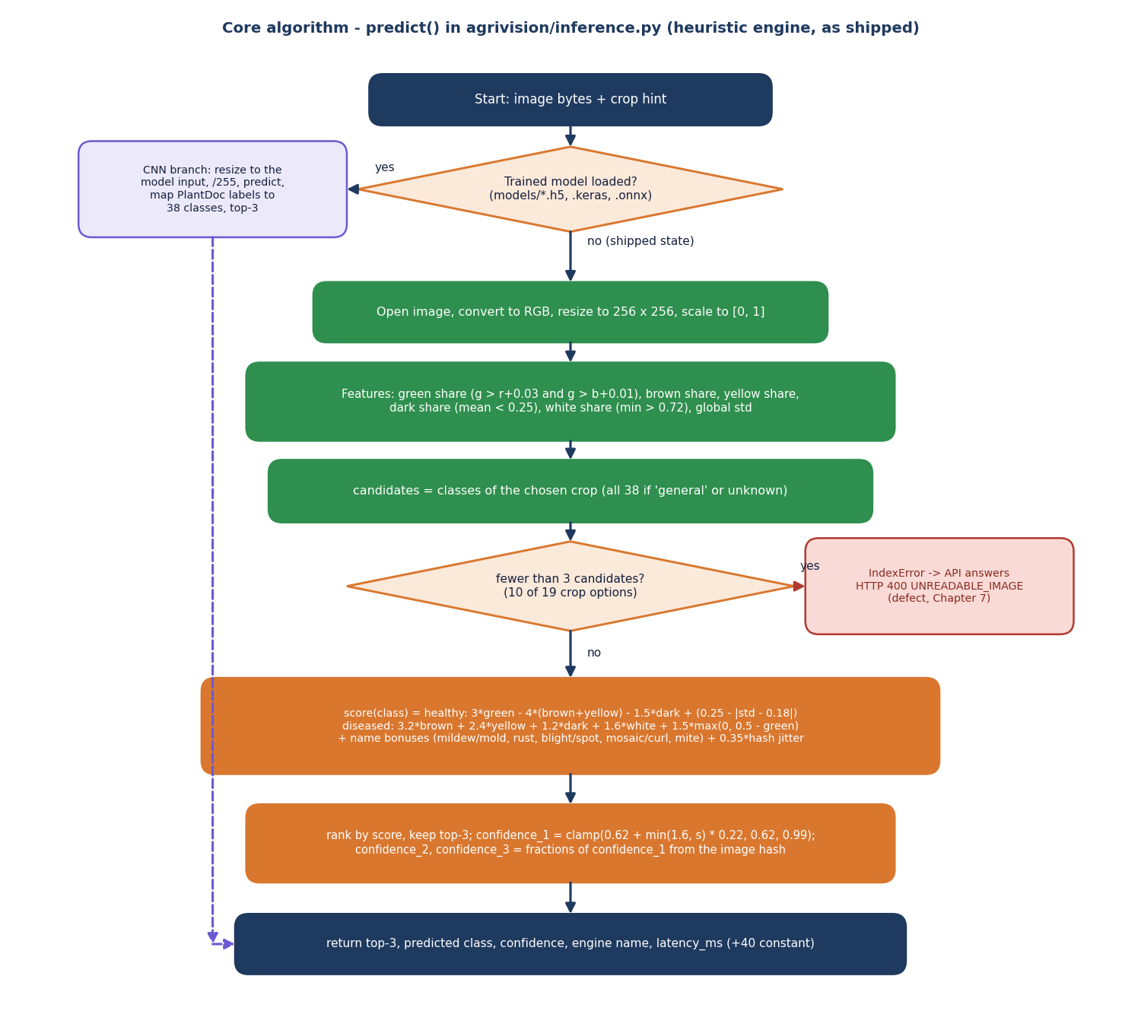
Figure 10: Flowchart of predict() in agrivision/inference.py (the shipped heuristic engine).
The flowchart follows predict(). If a Keras or ONNX model file is present the image is resized to the model input, scaled to [0, 1], passed through the network and the three largest outputs are mapped to the 38 classes. Otherwise, as shipped, the image is converted to RGB and resized to 256 x 256, six features are measured, the candidate classes of the chosen crop are selected, and a hand-written score is computed for each candidate. The three highest scores are kept, the first confidence is the clamped value 0.62 + 0.22 min(1.6, s), and the other two are fractions of it taken from the image hash. If fewer than three candidates exist the ranking raises an IndexError, which the API reports as HTTP 400 UNREADABLE_IMAGE.
The design deliberately keeps the engine behind one function. The formulas in the flowchart are written out in Section 6.6; the measured behaviour is in Chapter 8, and the consequences of the fewer-than-three-candidates branch are discussed under defect D1 in Chapter 7.

1.10 Deployment design
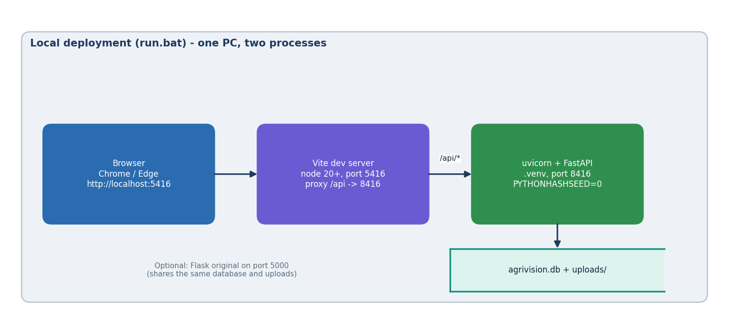
Figure 11: Local deployment of AgriVision started by run.bat.
run.bat creates a Python virtual environment, installs the backend requirements and the frontend packages, and starts two processes on one PC: uvicorn serving the FastAPI application on port 8416 with PYTHONHASHSEED=0 (so the heuristic's hash jitter is the same in every run) and the Vite server on port 5416 that proxies /api to it. The browser opens http://localhost:5416. The SQLite file and the upload folder are local to the machine. The original Flask application can be started on port 5000 and shares the same database and uploads. Nothing in this setup is suitable for several simultaneous users without a production web server and a different database.

1.11 User interface design
The interface follows the Aurora Glass design kit: translucent cards on a dark or light gradient background, an emerald, teal and lime accent palette (remapped from the kit's violet) and a sidebar that collapses to a bottom navigation bar on phone-sized screens. Every screen has the same shell: sidebar, a breadcrumb bar with the API status, language menu, theme toggle and user menu. The design rules were: one primary action per screen, large touch targets, plain words, the engine note always visible, and no information carried by colour alone (severity badges carry a text label).
Table 11: Screen map
Screen | Route | Purpose | Needs sign-in
Landing | / | Product story, live disease-guide teaser, how it works | no
Login, Register | /login, /register | Sign in (demo account hint) or create an account with crop and language | no
Dashboard | /dashboard | Totals, quick scan buttons, field tips, recent scans | yes
Detect | /detect | Choose crop, drop or capture a photo, diagnose | yes
Result | /result/{id} | Diagnosis, top three, symptoms, treatments, exports | yes
History | /history | Search, crop and healthy/diseased filters, delete, export | yes
Analytics | /analytics | Disease distribution, severity split, scans per day | yes
Profile | /profile | Name, region, language, monitored crops | yes
Disease guide, Detail | /encyclopedia, /disease/{class} | 38 searchable cards and a full treatment page | no

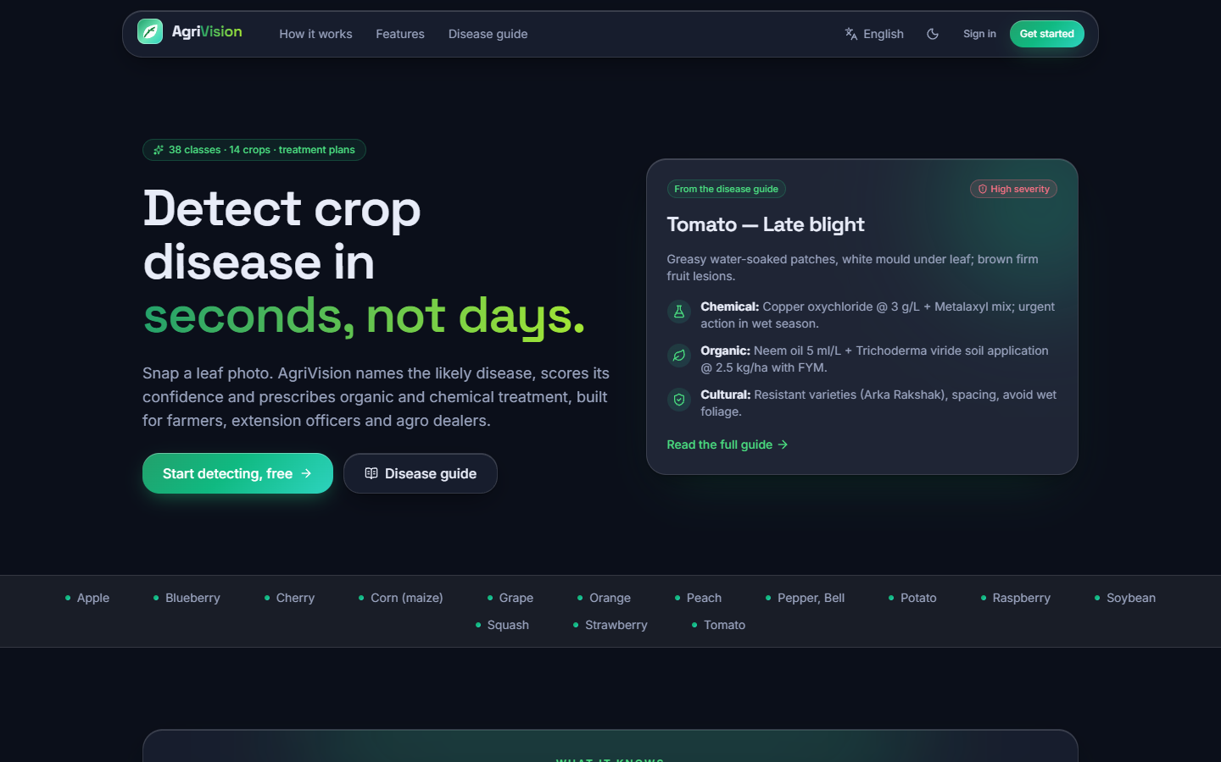  Figure 12: Landing page (dark theme). | 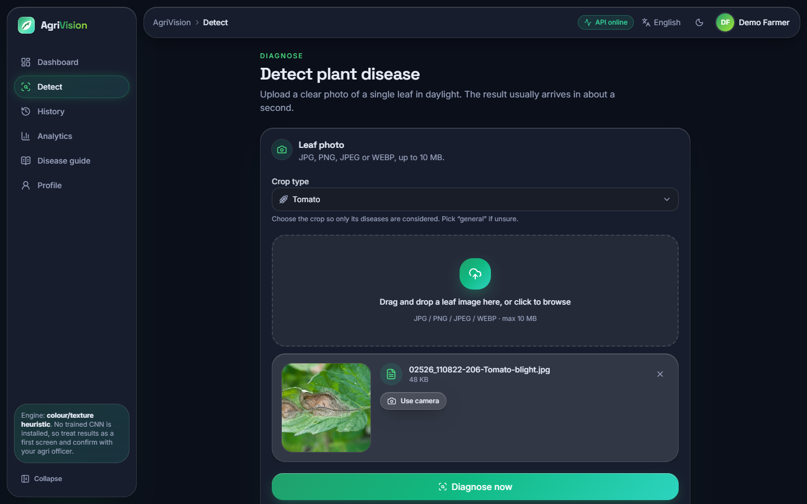  Figure 13: Detect screen with a photograph chosen and the crop selected.

Only the 44 interface keys are translated into Hindi and Marathi, so field tips, treatments and symptom text remain in English (see Chapter 10). Every other screen, including the Hindi and phone-width captures, is shown in Chapter 8 and Appendix C.

2. IMPLEMENTATION

2.1 Application architecture
The runtime has two processes (Figure 12 of the diagram set). The FastAPI process imports config, inference, disease_db and app.init_db from agrivision/ by adding that folder to sys.path, so there is exactly one implementation of detection, of the knowledge base and of the tables. Environment variables AGRIVISION_DB, AGRIVISION_UPLOADS and AGRIVISION_SECRET can redirect the database, the upload folder and the token secret; the tests use the first two to work on a throw-away copy. Each request opens its own SQLite connection (get_db) and closes it afterwards. On the browser side, axios sends every call to /api, which Vite proxies to port 8416; TanStack Query caches the results of reads, and a mutation that creates or deletes a scan invalidates the dashboard, history and analytics queries.

2.1.1 Diagnosis request
detect() is the heart of the service. It rejects a missing or empty file (400), an extension outside jpg, jpeg, png and webp (400) and a body above 10 MB (413), calls predict(), looks up the card of the predicted class, writes the image under a random UUID name, inserts the row and returns the summary. The excerpt shows the code as shipped, including the broad except that turns any engine exception into 400 UNREADABLE_IMAGE (defect D1). The full listing is in Appendix A.2.

2.1.2 Engine hook for a trained model
try_load_model() runs once when inference is imported. If models/plantdoc_cnn.h5 and labels.json (written by train.py) exist, TensorFlow is imported, the model is loaded without its optimiser and predict() takes the network branch: resize to the model's input size, scale to [0, 1], predict, take the three largest outputs and translate PlantDoc names to canonical labels with PLANTDOC_MAP. /api/health then reports trained_model: true and the interface changes its wording. No code outside inference.py needs to change.

2.2 API design in the code
Routes are plain FastAPI functions. Authentication is a dependency (current_user) shared by every protected route, so a route cannot forget it. Ownership is checked by owned(), which selects with both the scan id and the user id and answers 404 for anything else. History filters (search text, crop, healthy or diseased) are applied in Python over the user's rows, the same rule as the Flask page, which is adequate for hundreds of scans and would have to move into SQL for tens of thousands. Exports are generated on the fly: csv from the standard library and a one-page PDF per scan with reportlab. A single exception handler turns every HTTPException into {error, message, detail}.
def make_token(uid: str) -> str:
payload = base64.urlsafe_b64encode(json.dumps({"uid": uid, "exp": int(time.time()) + TOKEN_TTL}).encode()).decode()
sig = hmac.new(SECRET, payload.encode(), hashlib.sha256).hexdigest()
return f"{payload}.{sig}"

def read_token(token: str) -> str | None:
try:
payload, sig = token.split(".", 1)
good = hmac.new(SECRET, payload.encode(), hashlib.sha256).hexdigest()
if not hmac.compare_digest(sig, good):
return None
data = json.loads(base64.urlsafe_b64decode(payload.encode()))
return data["uid"] if data["exp"] > time.time() else None
except Exception:
return None

2.3 Security and error handling
Table 12: Security measures in the code and their limits
Concern | Implementation | Limit found by the tests
Passwords | Salted hash by werkzeug.security (scrypt); minimum 6 characters; never returned | No complexity rule, no lock-out (defect D4)
Sessions | HMAC-SHA256 bearer token with 7-day expiry, compared in constant time; forged, malformed and expired tokens give 401 | Default secret agrivision-dev-secret-change-me is public: a token signed with it is accepted unless AGRIVISION_SECRET is set (D3); no revocation list
Authorisation | Every scan query includes user_id; other users get 404 on read, export and delete | Uploaded images are served without a token; the random file name is the only protection
Uploads | Extension whitelist, 10 MB limit, empty-file check, random server-side file name; a path inside the file name does not escape the folder | The file content is not checked separately: a text file renamed .jpg is refused only because Pillow cannot open it (400 UNREADABLE_IMAGE)
Injection | All SQL uses ? parameters; search text is compared in Python | None found
Cross-origin | CORS allows only http(s)://localhost and 127.0.0.1 origins | A deployment on another host must edit the pattern
Errors | One JSON error shape; the client shows message; a 401 on a signed-in call drops the token and returns to sign-in | The broad except in detect() reports every engine failure as an unreadable image

On the client, validate() in the Detect page repeats the extension and size checks before upload and shows the sentence returned by the service when a request fails; a progress bar follows the upload; and an expired token is removed from storage and the sign-in page is shown.

2.4 Installation and execution
1. Install Python 3.10 or newer and Node.js 20 or newer.
2. Double-click run.bat in 8.ProjectCode. It sets PYTHONHASHSEED=0, creates or rebuilds .venv, installs backend/requirements.txt (FastAPI, uvicorn, python-multipart, Flask, Pillow, NumPy, reportlab) and runs npm install in frontend/.
3. It starts the API on port 8416 (waits for /api/health) and the Vite server on port 5416 and opens http://localhost:5416. Ports come from .env.
4. Sign in with the demo account demo@agrivision.ai / demo1234 or register.
5. To use a network: pip install tensorflow, run python agrivision/train.py (it needs datasets/plantdoc-images), then restart the API.
Checks: python scripts/smoke_test.py (39 API checks, own server and throw-away database), python scripts/edge_tests.py (51 unit and API checks), python scripts/ui_checks.py (55 browser checks, both servers needed) and python scripts/run_experiments.py for the measurements. Appendix B gives the step-by-step guide.

3. KEY CODE WALK-THROUGHS

3.1 Signed bearer token
The API does not use a library for sessions. make_token encodes the user id and an expiry (seven days) as base64 JSON and appends an HMAC-SHA256 signature computed with a server secret; read_token recomputes the signature, compares it in constant time and checks the expiry. current_user reads the Authorization: Bearer header, resolves the id against the users table and refuses inactive accounts with HTTP 401. The scheme is small and testable, but its safety rests entirely on the secret: the default value in config.py is public (defect D3).
def make_token(uid: str) -> str:
payload = base64.urlsafe_b64encode(json.dumps({"uid": uid, "exp": int(time.time()) + TOKEN_TTL}).encode()).decode()
sig = hmac.new(SECRET, payload.encode(), hashlib.sha256).hexdigest()
return f"{payload}.{sig}"

def read_token(token: str) -> str | None:
try:
payload, sig = token.split(".", 1)
good = hmac.new(SECRET, payload.encode(), hashlib.sha256).hexdigest()
if not hmac.compare_digest(sig, good):
return None
data = json.loads(base64.urlsafe_b64decode(payload.encode()))
return data["uid"] if data["exp"] > time.time() else None
except Exception:
return None

def current_user(request: Request, con: sqlite3.Connection = Depends(get_db)) -> dict:
auth = request.headers.get("authorization", "")
uid = read_token(auth[7:]) if auth.lower().startswith("bearer ") else None
row = con.execute("SELECT * FROM users WHERE id=? AND is_active=1", (uid,)).fetchone() if uid else None
if not row:
raise err(401, "AUTHENTICATION_REQUIRED", "Please sign in to continue.")
return dict(row)

3.2 The detection endpoint
detect is the only route that changes both disk and database. It rejects a missing or empty file, a disallowed extension (400) and a file over 10 MB (413), calls predict, and turns any exception into HTTP 400 'unreadable image' - which is how defect D1 surfaces for a valid photograph. It then looks up the knowledge card of the top-1 class, writes the upload under a random UUID name (so the URL is the capability), inserts one results row with the top-3 list as JSON and returns the card's treatments.
@app.post("/api/v1/detect/upload")
async def detect(image: UploadFile = File(None), crop_type: str = Form("general"),
user: dict = Depends(current_user), con: sqlite3.Connection = Depends(get_db)):
if image is None or not image.filename:
raise err(400, "NO_IMAGE", "Choose a leaf image first.")
ext = image.filename.rsplit(".", 1)[-1].lower()
if ext not in config.ALLOWED_EXT:
raise err(400, "INVALID_IMAGE_FORMAT", "Image must be JPG, PNG, JPEG or WEBP (max 10 MB).")
data = await image.read()
if len(data) > config.MAX_CONTENT_LENGTH:
raise err(413, "IMAGE_TOO_LARGE", "That image is over 10 MB. Use a smaller photo.")
if not data:
raise err(400, "NO_IMAGE", "The file is empty.")
try:
out = predict(data, crop_type)
except Exception:
raise err(400, "UNREADABLE_IMAGE", "That file could not be read as an image. Try another photo.")
info = get_disease_info(out["predicted"])
name = f"{uuid.uuid4().hex}.{ext if ext != 'webp' else 'png'}" # same naming rule as Flask's /detect
with open(os.path.join(config.UPLOAD_DIR, name), "wb") as fh:
fh.write(data)
rid = str(uuid.uuid4())
con.execute("INSERT INTO results VALUES(?,?,?,?,?,?,?,?,?,?,?,?)",
(rid, user["id"], f"static/uploads/{name}", len(data), out["predicted"], out["confidence"],
json.dumps(out["top3"]), info["severity"], crop_type, out["latency_ms"],
datetime.utcnow().isoformat(), 0))
con.commit()
return {"result_id": rid, "predicted_disease": info["name"], "confidence": out["confidence"],
"top_3_predictions": [{"disease": display_name(c), "confidence": p} for c, p in out["top3"]],
"severity": info["severity"], "processing_time_ms": out["latency_ms"],
"recommendations": {"treatments": info["treatments"], "prevention": info["prevention"],
"urgent_action": info["urgent"]},
"engine": out.get("engine", engine_name())}

3.3 Feature extraction
The heuristic reduces a photograph to six numbers on a 256 x 256 copy: the share of pixels that are greener than red and blue, brownish, yellowish, dark and near-white, and the overall standard deviation. These are cheap and explainable, but they confuse a lesion with soil, a shadow or a pale leaf.
def _features(img: Image.Image) -> dict:
img = img.convert("RGB").resize((256, 256))
a = np.asarray(img).astype(np.float32) / 255.0
r, g, b = a[..., 0], a[..., 1], a[..., 2]
green_mask = (g > r + 0.03) & (g > b + 0.01)
green_ratio = float(green_mask.mean())
brown = ((r > 0.35) & (g < 0.55) & (g > 0.15) & (r > g) & ((r - g) > 0.08)).mean()
yellow = ((r > 0.5) & (g > 0.5) & (b < 0.4)).mean()
dark = (a.mean(axis=-1) < 0.25).mean()
white = (a.min(axis=-1) > 0.72).mean()
var = float(a.std())
return dict(green=green_ratio, brown=float(brown), yellow=float(yellow),
dark=float(dark), white=float(white), var=var)

3.4 Scoring and calibration
For each candidate class the score is a hand-written linear formula: a healthy class gains from green and loses from brown, yellow and dark pixels; a diseased class gains from brown, yellow, dark and white pixels, with bonuses for words in its name (mildew, rust, blight, mosaic, mite). A hash-based jitter keeps the order stable per image. The top score is then mapped into 0.62 to 0.99, which is why almost every answer shows 97 %; the second and third values are fractions of the first taken from the image hash, which is why the three scores add up to more than 100 % (D2). When a crop has fewer than three candidates ranked[1] does not exist and the function raises (D1).
def _heuristic_predict(img_bytes: bytes, crop_hint: str):
img = Image.open(io.BytesIO(img_bytes))
f = _features(img)
cands = _candidates(crop_hint)
h = int(hashlib.md5(img_bytes).hexdigest()[:8], 16)

def score(cls: str) -> float:
c = cls.lower()
s = 0.0
healthy = "healthy" in c
if healthy:
s += f["green"] * 3.0 - (f["brown"] + f["yellow"]) * 4.0 - f["dark"] * 1.5 + (0.25 - abs(f["var"] - 0.18))
else:
s += (f["brown"] * 3.2 + f["yellow"] * 2.4 + f["dark"] * 1.2 + f["white"] * 1.6)
s += max(0.0, (0.5 - f["green"])) * 1.5
if "mildew" in c or "mold" in c:
s += f["white"] * 2.0
if "rust" in c:
s += f["brown"] * 1.5
if "blight" in c or "spot" in c or "scorch" in c:
s += (f["brown"] + f["yellow"]) * 1.2
if "mosaic" in c or "curl" in c or "greening" in c:
s += f["yellow"] * 1.8
if "mite" in c:
s += (f["yellow"] + f["white"]) * 1.0
# deterministic jitter so top-3 is stable per image
j = ((h ^ hash(cls)) % 1000) / 1000.0
return s + j * 0.35

ranked = sorted(cands, key=score, reverse=True)[:3]
top_s = score(ranked[0])
# calibrate to 0.62–0.99 range
conf1 = float(min(0.99, max(0.62, 0.62 + min(1.6, top_s) * 0.22)))
conf2 = round(conf1 * (0.04 + ((h >> 3) % 8) / 100), 4)
conf3 = round(conf1 * (0.01 + ((h >> 6) % 4) / 100), 4)
conf1 = round(conf1, 4)
rem = max(0.0, round(1 - conf1 - conf2 - conf3, 4))
return [(ranked[0], conf1), (ranked[1], conf2), (ranked[2], conf3)], f, rem

3.5 Knowledge card
get_disease_info assembles the card from a curated override where one exists and from five generic kinds otherwise, so every class returns three treatments, a prevention note, a lifecycle text and a severity; an unknown class silently falls back to 'Tomato healthy', which hides errors.
def get_disease_info(cls: str) -> dict:
"""Return full info card for a class label."""
if cls not in CLASSES:
cls = "Tomato___healthy"
crop_raw, _, dis_raw = cls.partition("___")
crop = display_name(cls).split(" — ")[0]
disease = display_name(cls).split(" — ")[1]
kind = _kind_of(cls)
ov = _OVERRIDES.get(cls, {})
healthy = kind == "healthy"
severity = "none" if healthy else ov.get("severity", "medium")
symptoms = ov.get("symptoms") or (
"No visible symptoms. Uniform green colour, intact margins, normal vigour."
if healthy else
f"Typical {disease.lower()} lesions on foliage (spots/blight/mould pattern); "
"reduced photosynthesis, premature leaf drop and yield loss if unmanaged."
)
chem, org = _GENERIC_TREATMENTS[kind]
chemical = ov.get("treatment_chemical", chem)
return {
"class": cls,
"name": display_name(cls),
"crop": crop,
"disease": "Healthy" if healthy else disease,
"healthy": healthy,
"severity": severity,
"description": (
f"{crop} crop showing no disease — leaf tissue is healthy." if healthy
else f"{disease} is a {kind} disorder of {crop.lower()} causing foliar lesions and yield loss. Early detection and prompt treatment prevent spread."
),
"symptoms": symptoms,
"treatments": [
{"name": chemical.split(";")[0][:90], "type": "chemical", "detail": chemical, "cost": "₹250–₹600 / acre / spray"},
{"name": org.split(";")[0][:90], "type": "organic", "detail": org, "cost": "₹150–₹400 / acre"},
{"name": "Cultural control", "type": "cultural",
"detail": ov.get("prevention", "Crop rotation, clean seed, balanced fertilisation, drip irrigation, field sanitation, resistant varieties."),
"cost": "Low / preventive"},
],
"prevention": ov.get("prevention", "Use certified seed, rotate crops, avoid overhead irrigation, scout weekly, remove debris."),
"lifecycle": (
"N/A — healthy tissue." if healthy
else "Pathogen survives on debris/seed or alternate hosts; spreads by wind, rain-splash, insects or sap; favoured by warm humid canopy. Break the cycle with sanitation + rotation."
),
"urgent": severity == "high",
}

3.6 The compact CNN
build_model stacks five depthwise-separable convolution blocks (32 to 256 filters) with batch normalisation, max-pooling and dropout, global average pooling and a 256-unit dense layer, in the spirit of efficient mobile networks [10], [9]. Augmentation layers are part of the model and only act in training. The network has 189,655 parameters and 2.4 MB on disk.
def build_model(num_classes: int, img_size: int = 224):
"""Compact CNN (~1.1M params): depthwise-separable blocks + GAP head."""
import tensorflow as tf
from tensorflow import keras
inp = keras.Input(shape=(img_size, img_size, 3))
x = keras.layers.Rescaling(1.0 / 255)(inp)
# light on-model augmentation (train-time only effect via training=True)
aug = keras.Sequential([
keras.layers.RandomFlip("horizontal"),
keras.layers.RandomRotation(0.08),
keras.layers.RandomZoom(0.1),
keras.layers.RandomContrast(0.1),
])
x = aug(x)
for filters, stride in [(32, 2), (64, 1), (128, 2), (256, 2), (256, 1)]:
x = keras.layers.SeparableConv2D(filters, 3, strides=stride, padding="same", activation="relu")(x)
x = keras.layers.BatchNormalization()(x)
x = keras.layers.MaxPooling2D(2, padding="same")(x)
x = keras.layers.Dropout(0.15)(x)
x = keras.layers.GlobalAveragePooling2D()(x)
x = keras.layers.Dropout(0.3)(x)
x = keras.layers.Dense(256, activation="relu")(x)
out = keras.layers.Dense(num_classes, activation="softmax")(x)
model = keras.Model(inp, out, name="PD36-C-plantdoc")
model.compile(optimizer=keras.optimizers.Adam(1e-3),
loss="sparse_categorical_crossentropy",
metrics=["accuracy"])
return model

3.7 Evaluation code
metrics_from_preds computes the confusion matrix and, from it, per-class precision, recall and F1, macro and weighted F1 over the classes that have test photographs, and top-3 accuracy. Classes without test photographs (spider mites) are excluded from the macro average rather than counted as zero.
def metrics_from_preds(y_true, y_pred, probs=None, names=None):
"""accuracy, macro/weighted F1, per-class P/R/F1, confusion matrix, top-3 (if probs)."""
import numpy as np
n = len(names)
y_true, y_pred = np.asarray(y_true), np.asarray(y_pred)
cm = np.zeros((n, n), dtype=int)
for t, p in zip(y_true, y_pred):
cm[t, p] += 1
per = {}
f1s, ws, present = [], [], []
for i in range(n):
tp = cm[i, i]
fp = cm[:, i].sum() - tp
fn = cm[i, :].sum() - tp
pr = tp / (tp + fp) if tp + fp else 0.0
rc = tp / (tp + fn) if tp + fn else 0.0
f1 = 2 * pr * rc / (pr + rc) if pr + rc else 0.0
sup = int(cm[i, :].sum())
per[names[i]] = dict(precision=pr, recall=rc, f1=f1, support=sup)
if sup:
f1s.append(f1)
ws.append(sup)
present.append(i)
out = dict(n=int(len(y_true)), accuracy=float((y_true == y_pred).mean()),
macro_f1=float(np.mean(f1s)), weighted_f1=float(np.average(f1s, weights=ws)),
macro_precision=float(np.mean([per[names[i]]["precision"] for i in present])),
macro_recall=float(np.mean([per[names[i]]["recall"] for i in present])),
per_class=per, confusion=cm.tolist(), classes=list(names))
if probs is not None:
top3 = np.argsort(-np.asarray(probs), axis=1)[:, :3]
out["top3_accuracy"] = float(np.mean([t in row for t, row in zip(y_true, top3)]))
return out

4. IMPLEMENTATION DECISIONS AND THEIR REASONS
The table lists the decisions that shaped the implementation, the alternatives and why each was taken or accepted.
Table 13: Implementation decisions
Decision | Alternative | Reason and consequence
FastAPI layer over the original Flask product | Rewrite the product, or extend Flask | The detection, knowledge and database code already existed; importing it avoids a second copy and keeps the Flask pages working. Consequence: the Flask quirks (positional INSERT, UNREADABLE_IMAGE mapping) are inherited.
React single-page application with a Vite proxy to /api | Server-rendered Flask templates | Faster interaction, charts and responsive layout; no CORS or port constants in the browser code.
SQLite with two tables | PostgreSQL | Zero set-up on a student PC; one file shared by both front ends. Not suitable for several servers.
Heuristic engine as the default, Keras or ONNX model when present | Block the product until a model exists | The application stays demonstrable and the engine is swappable by dropping a file. Consequence: the shipped answers are close to chance, so the interface says 'Heuristic engine' everywhere.
Knowledge base in Python code | Database table or CMS | Versioned with the code and available without a database; an agronomist cannot edit it without a developer.
HMAC-signed bearer token, seven days | Server sessions or a JWT library | Stateless and about 20 lines; no revocation, and safe only if the secret is set (D3).
PYTHONHASHSEED=0 in run.bat | Remove the hash from the score | Keeps the hash-based jitter of the heuristic identical between runs; the root cause (using hash()) remains.
Interface strings translated, advice text not | Translate the knowledge base | A 44-key dictionary is cheap and safe; translating agronomic advice needs expert review.
Random file names for uploads, served without a token | Authenticated file route | Simple <img> tags; the unguessable name is the capability.
Experiments with a 10 % validation split from the train folder | Select on the test folder as train.py does | Keeps the 236 test photographs untouched; costs 10 % of the training data.
MobileNetV2 as the reference model | EfficientNet or a larger backbone | ImageNet weights are available, the model is small (2.29 million parameters) and trains in about 12 minutes on CPU.

